**University of Michigan – Dearborn**

**CIS 150 – Computer Science 1**

**Lab# 11**

Quan Le

[lmmquan@umich.edu](mailto:lmmquan@umich.edu)

March 26, 2024

**Table Content**

Contents

Question 1 3

Test Cases 3

Source Code 3

Screenshots 3

# Question 1

## Test Cases

|  |  |  |  |  |  |
| --- | --- | --- | --- | --- | --- |
| Test # | Valid / Invalid Data | Description of test | Input Value | Actual Output | Test Pass / Fail |
| 1 | Valid | Option 1 | choice = 1  abrv = CA | Print all the info about California | Pass |
| 2 | Valid | Option 2 | choice = 2  year = 1788 | Print all the info about Connecticut, Georgia, Maryland, Massachusetts, New Hampshire, New York, South Carolina and Virginia | Pass |
| 3 | Valid | Option 2 | choice = 2  year = 2018 | No state exists with this information | Pass |
| 4 | Valid | Option 3 | choice = 3 | Exiting program | Pass |

## Source Code

The source code for this question has been uploaded to Canvas as main.cpp, state.cpp and state.h.

## Screenshots

Test Case #1

Test Case #2

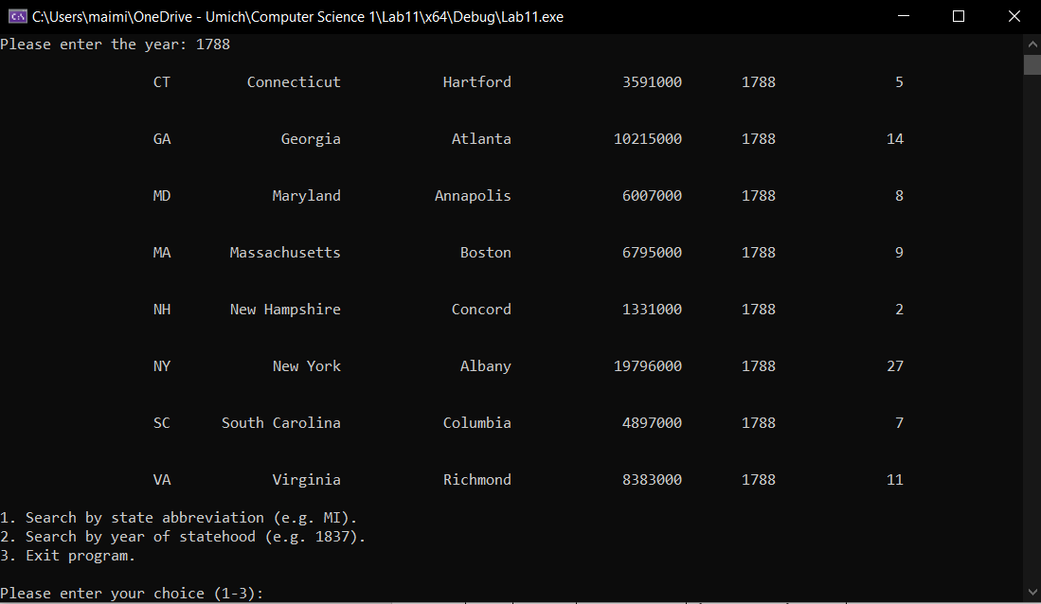

Test Case #3

Test Case #4

